Impact of Session 0 Isolation on Services and Drivers in Windows Vista
March 17, 2006
Abstract
In Microsoft® Windows Server™ 2003 and earlier versions of Microsoft Windows®, all services run in Session 0 along with applications, which poses a security risk. Microsoft Windows Vista™ isolates services in Session 0 and runs applications in other sessions, so services are protected from attacks that originate in application code.
This paper describes changes to the way in which services are run in Windows Vista. It provides guidelines for developers to modify application services and driver services to run in Windows Vista.
Future versions of this preview information will be provided in the Windows Driver Kit (WDK).
The current version of this paper is maintained on the Web at:
http://www.microsoft.com/whdc/system/vista/
References and resources discussed here are listed at the end of this paper.
Contents
Introduction 3
Implications for Services and Service-Hosted Drivers 4
What Is Affected 4
Potential Issues 5
Guidelines for Services and Service-Hosted Drivers in Windows Vista 5
Interactive Service Detection Service 6
Resources 7

Disclaimer

This is a preliminary document and may be changed substantially prior to final commercial release of the software described herein.

The information contained in this document represents the current view of Microsoft Corporation on the issues discussed as of the date of publication. Because Microsoft must respond to changing market conditions, it should not be interpreted to be a commitment on the part of Microsoft, and Microsoft cannot guarantee the accuracy of any information presented after the date of publication.

This White Paper is for informational purposes only. MICROSOFT MAKES NO WARRANTIES, EXPRESS, IMPLIED OR STATUTORY, AS TO THE INFORMATION IN THIS DOCUMENT.

Complying with all applicable copyright laws is the responsibility of the user. Without limiting the rights under copyright, no part of this document may be reproduced, stored in or introduced into a retrieval system, or transmitted in any form or by any means (electronic, mechanical, photocopying, recording, or otherwise), or for any purpose, without the express written permission of Microsoft Corporation.

Microsoft may have patents, patent applications, trademarks, copyrights, or other intellectual property rights covering subject matter in this document. Except as expressly provided in any written license agreement from Microsoft, the furnishing of this document does not give you any license to these patents, trademarks, copyrights, or other intellectual property.

Unless otherwise noted, the example companies, organizations, products, domain names, e-mail addresses, logos, people, places and events depicted herein are fictitious, and no association with any real company, organization, product, domain name, email address, logo, person, place or event is intended or should be inferred.

© 2005 Microsoft Corporation. All rights reserved.

Microsoft, Win32, Windows, Windows Server, Windows Server code named "Longhorn", and Windows Vista are either registered trademarks or trademarks of Microsoft Corporation in the United States and/or other countries.

The names of actual companies and products mentioned herein may be the trademarks of their respective owners.

Introduction
In Microsoft® Windows® XP, Microsoft Windows Server™ 2003, and earlier versions of the Windows operating system, all services run in the same session as the first user who logs on to the console. This session is called Session 0. Running services and user applications together in Session 0 poses a security risk because services run at elevated privilege and therefore are targets for malicious agents who are looking for a way to elevate their own privilege level.
The Microsoft Windows Vista™ operating system mitigates this security risk by isolating services in Session 0 and making Session 0 noninteractive. In Windows Vista, only system processes and services run in Session 0. The first user logs on to Session 1, and subsequent users log on to subsequent sessions. This means that services never run in the same session as users’ applications and are therefore protected from attacks that originate in application code.
The following figures illustrate the changes. In Windows XP and Windows Server 2003, sessions are assigned as follows:
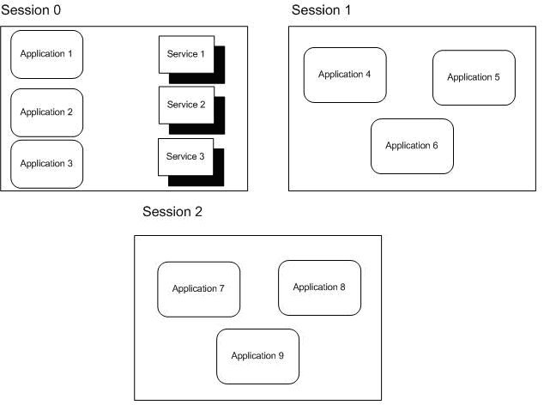
Figure 1. Sessions in Windows XP and Windows Server 2003
Figure 1 illustrates what happens with three users logged on to the system. Session 0 contains both user applications and services. On a system that is running Windows Server 2003, Session 0 is the console session and Sessions 1 and 2 represent remote users. On a system that is running Windows XP with Fast User Switching (FUS) enabled, the first user to log on is assigned to Session 0 and Sessions 1 and 2 represent other users who have logged on to the local system.
In Windows Vista, sessions are assigned as follows:
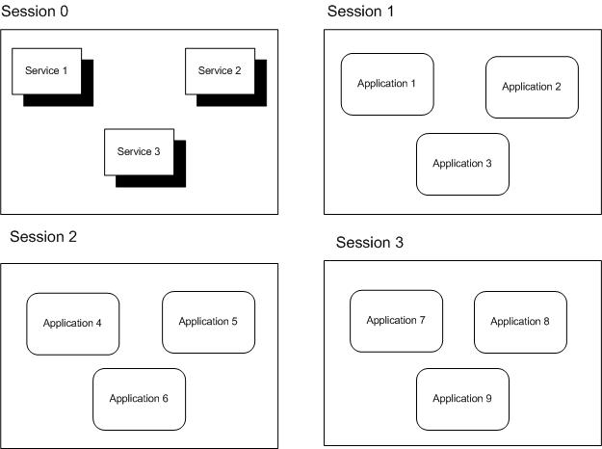
Figure 2. Sessions in Windows Vista
In Figure 2, again three users are logged on to the system. However, only services run in Session 0. The first user logs on to Session 1, and Sessions 2 and 3 represent subsequent users.
Because Session 0 is no longer a user session in Windows Vista, services that are running in Session 0 do not have access to the video driver in Windows Vista. This means that any attempt that a service makes to render graphics fails. In current builds of Windows Vista, querying the display resolution and color depth in Session 0 reports the correct results for the system up to a maximum of 1920x1200 at 32 bits per pixel (bpp).

Implications for Services and Service-Hosted Drivers

What Is Affected
Any applications or drivers that are installed as a service are affected by the following implications. Some drivers are loaded within operating system services or processes that are running in Session 0, and those drivers are also affected by the implications of the Session 0 changes. Specific examples of affected driver classes include:
- Printer drivers, which are loaded by the spooler service.
- All drivers that are authored with the User-Mode Driver Framework (UMDF) because these drivers are hosted by a process in Session 0.

Potential Issues
Any functionality in a service or a service-hosted driver that assumes the user is running in Session 0 does not work correctly in Windows Vista. Some examples of places where this assumption might occur are:
- A service attempts to create a user interface (UI), such as a dialog box, in Session 0. Because the user is not running in Session 0, he or she never sees the UI and therefore cannot provide the input that the service is looking for. The service appears to stop functioning because it is waiting for a user response that does not occur.
For example, if a device installer runs in Session 0 and the installation program creates a dialog box in Session 0 that requires user input to continue, the device installation never completes because the user does not see the dialog box. From the user’s perspective, the device installer is hung because it has stopped progressing and the user has no way to resume it.
- A service tries to use window message functions such as SendMessage and PostMessage to communicate with an application. This does not work because the application is running in a different session and therefore has a different message queue. The messages never arrive at their destination. The same is true for applications that try to communicate with services through window messages.
- Because services run in Session 0, named objects created or opened by services are usually in \BaseNamedObjects\. However, if a user application assumes that it is running in the same session as the service and synchronizes with the service by creating or opening objects with the Local\ prefix (or no prefix, which defaults to Local\), the application no longer works as expected. This is because the create or open request is specific to that session (due to the Local\ prefix) and the objects that the application creates or opens are in \Sessions\<n>\BaseNamedObjects instead of \BaseNamedObjects\. The correct way for user applications to synchronize with a service is to explicitly use the Global\ prefix when creating or opening objects in \BaseNamedObjects\.

These implications for services are also exposed through FUS in Windows XP because every user on a FUS-enabled machine runs in a different session. Services that assume that the user is running in Session 0 encounter the same issues when the second user logs on to a FUS-enabled machine. However, services that were not fixed to work with FUS encounter problems in Windows Vista even if only one user is logged on.

Guidelines for Services and Service-Hosted Drivers in Windows Vista
To work properly in Windows Vista, drivers that are hosted within a service should follow these guidelines:
- Use a client/server mechanism such as remote procedure call (RPC) or named pipes rather than window messages to communicate with applications.
- Implement any necessary user interface for the service as follows:
- Use the WTSSendMessage function to create a simple message box on the user’s desktop. This allows the service to give the user a notification and request a simple response.
- For more complex UI, use the CreateProcessAsUser function to create a process in the user’s session. The process can then display a user interface in the user’s session. The service should use a client/server mechanism such as RPC or named pipes to obtain any response from the user.
- Query display properties in the user’s session, not in Session 0, because the resolution and color depth that are reported in Session 0 are unlikely to reflect the actual display properties.
- Explicitly choose either the Local\ or Global\ namespace for any named objects, such as events or mapped memory, that the service makes available. If an object must be accessible to user applications, it must be created in the Global\ namespace to be accessible to other sessions. The following Microsoft Win32® functions all accept named objects: OpenEvent, OpenMutex, OpenSemaphore, OpenWaitableTimer, OpenJobObject, and OpenFileMapping. Care should be taken when using these functions to ensure that the named object is accessible within the current session.
- Test the driver in Windows Vista to ensure that it runs properly. If that is not possible, test the driver in Windows XP with FUS enabled and multiple users logged on. If the driver works correctly for second and subsequent logged-on users, it is not likely to be affected by the Session 0 changes in Windows Vista. The only issues that this test does not detect are those related to the absence of the video driver in Session 0 in Windows Vista.

Interactive Service Detection Service
The option of enabling the Interactive Service Detection Service will be available for customers who have legacy services that send user interaction dialog boxes to Session 0 instead of the corresponding user’s session. This workaround will be removed from the next version of Windows, at which time all applications and drivers must handle Session 0 isolation properly.
In beta 2, the service will be demand start by default and will start only when a visible dialog box that is not a command window is detected. If the service is started, then users will be notified when a dialog box or window (including a command window) appears in Session 0. Information about each of the last ten dialog boxes will appear in turn if more information is shown. This will help ensure that beta testers are aware of legacy services in their environment and have the opportunity to contact the vendors for updated services.
The service will detect these visible dialog boxes or windows and send a notification to the user. Users may choose to:
- Respond to the dialog box immediately by clicking a button to switch to Session 0, interact with the task dialog box, and then switch back to their session.
- Be reminded again in 5 minutes. They will continue to be reminded until the dialog box closes.

Sessions on the glass—at the physical system—will always receive notification as long as the feature is not disabled. For Windows Vista client SKUs, the remote desktop session will be notified when the user is remote instead of on the glass. In Microsoft Windows Server code named "Longhorn" SKUs, the remote administration sessions will be notified if in use. When a Microsoft Terminal Services application server role is on the system, then only the administrative sessions will be notified and regular user sessions will never be notified.
After Interactive Services Detection Service is disabled, then users will no longer receive notifications when the devices/services send dialog boxes to Session 0.

Resources

Platform SDK
Services
http://msdn.microsoft.com/library/default.asp?url=/library/en-us/dllproc/base/services.asp
Synchronization
http://msdn.microsoft.com/library/default.asp?url=/library/en-us/dllproc/base/synchronization.asp
Making a Remote Procedure Call
http://msdn.microsoft.com/library/default.asp?url=/library/en-us/rpc/rpc/making_a_remote_procedure_call.asp
Client/Server Applications
http://msdn.microsoft.com/library/default.asp?url=/library/en-us/termserv/termserv/client_server_applications.asp
CreateProcessAsUser
http://msdn.microsoft.com/library/default.asp?url=/library/en-us/dllproc/base/createprocessasuser.asp
Test Your Application with Fast User Switching
http://msdn.microsoft.com/library/default.asp?url=/library/en-us/apcompat/apcompat/test_your_application_with_fast_user_switching.asp

Windows Driver Kit
Associating Services, Driver Packages, and Applications
http://msdn.microsoft.com/library/default.asp?url=/library/en-us/DevInst_d/hh/DevInst_d/difxapp_d8ccd250-0be4-4ce3-a893-857c4a57f4ce.xml.asp
INF AddService Directive
http://msdn.microsoft.com/library/default.asp?url=/library/en-us/devinst_r/hh/DevInst_r/inf-format_d7cb27c3-be3e-463a-85f6-6a5d5b11d8ed.xml.asp

